**Software Requirements Specification**

IDENTIFY COURSES PROJECT

|  |  |  |  |
| --- | --- | --- | --- |
|  | Prepared By | Reviewed By | Approved By |
| Name | Karempudi Bindu | Venkataraman |  |
| Role | Intern | Batch Trainer |  |

**Table of Contents**

Table of Contents…………………………………………………………..….......II

1. Introduction…………………………………………………………………..…1

1.1 Intended Audience……………………………………………….......1

1.2 Project Scope…………………………...……………………………1

2. Overall Description…………………………………………….……………….1

2.1 Operating Environment……………………...……………………....1

3. Requirements……………………………………………………………...…….1

3.1Login………………………………………………………………….2

3.1.1Description………………………………………………....2

3.1.2 Functional Requirements……..…………………………...2

**1. Introduction**

Coursera is an online learning website. We are taking and testing one functionality of that website (i.e.) Searching for Web Development courses. and also extract the look for the language learning

**1.1 Intended Audience**

Business Unit (BU) SME

Academy coach

Technical Trainer

**1.2 Project Scope**

This document defines at a functional level the business activities that are encompassed by the system and the rules that apply to them. It also encompasses some of the key high- and low-level technical requirements of the system.

It draws heavily on both proposed Framework and Business Rules and the Technical Architecture documents. The scope of the detailed analysis project phase specifies that this document will include.

· Classification of requirements according to their functional areas.

· A description of each process in the system, including their inputs, outputs, and data transformation rules.

**2. Overall Description**

**2.1 Operating Environment**

Windows operating system

Web application

**3. Requirements**

This part of the requirements document serves to present the "Coursera for web development courses" of the application and also we need to extract all the levels and languages in “Language Learning”.

**3.1.1 Functional Requirements**

**3.1.1.1 Req0001**

**Req0001a-**The user enters the text as “Web Development” in search box .

**Req0001b-** The user clicks “English” option under ‘Language’ menu

**Req0001c-**The user clicks “Beginner” option under ‘Level’ menu.

.

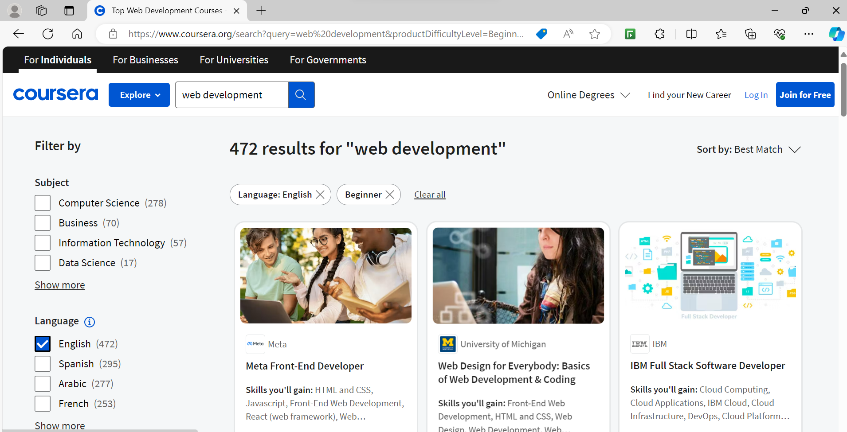

**Req0001d-** The user should get the details (course name, rating,Duration in hours) of first two courses

**3.1.1.2 Req0002**

**Req0002a**- The user clicks “Language learning” option under ‘Explore’ menu.

**Req0002b-** The user clicks “All language Courses” under ‘Popular skills’ menu.

**Req0002c-** The user clicks on “Show more” under ‘Language’ menu.

**Req0002d-** The user gets all languages from the popup and close the popup.

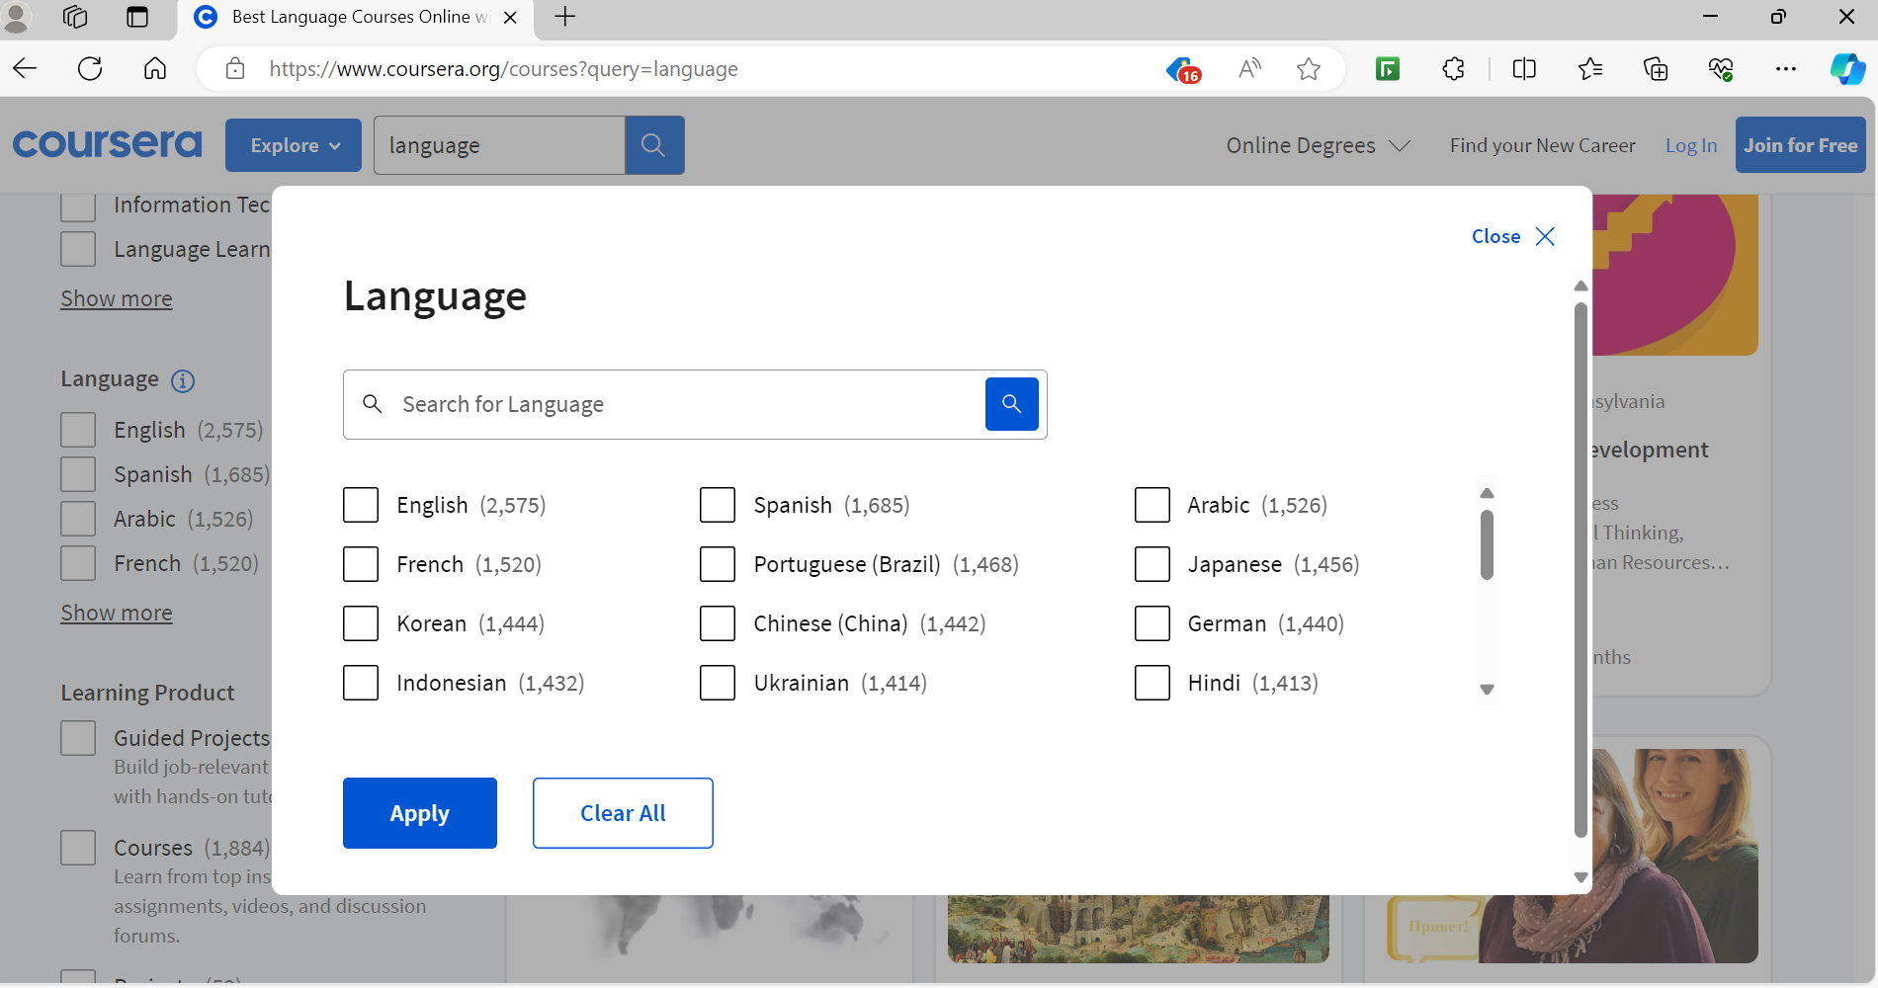

**Req0002e-** The user gets all levels under “Level” menu.

**3.1.2.3 Req0003**

**Req0003a**-The user clicks the “For Business” which will take to page.

**Req0003b-** The userclicks the “Contact sales” button.

**Req0003c-**It will navigate into the form.

**Req0003d-** The user fills the form with any one invalid input and capture the error message.

